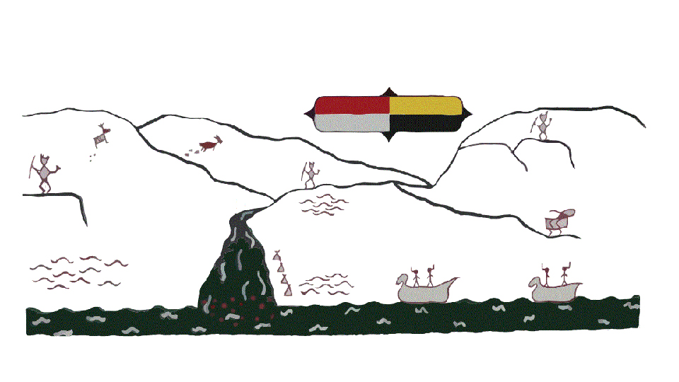
Kanaka Bar Indian Band

Cultural Wellness Support Worker
This position is primarily responsible for the guiding and engaging families, children, youth, and community members in culture activities promoting spiritual healing in a supportive and ethical manner. The Cultural Support Worker provides opportunities to share knowledge of the Nlaka’pamux culture, traditions, history, and protocols. The Cultural Support Worker will assist the KBIB Health team by designing age-appropriate activities that meet the cultural needs of the children and family by promoting culture through its implementation throughout programs for all ages, babies, families, youth, and Elderly. The ideal candidate will have experience in language, regalia making, weaving, crafts, foods, medicines, and other traditional practices.
Cultural Safety is an overarching goal of the Community Resiliency Plan and the Community Health and Wellness Plan. Customs, traditions, items, beliefs, and values that accurately portray Nlaka’pamux people will provide the foundation to program activities. The Cultural Wellness Support Worker will work with the health team and membership to develop community driven programs and services based on respectful dialogue and engagement. A strong focus will be on providing holistic activities that provide social and personal wellness in safe environments.
Key Duties and Responsibilities
- Promote and support traditional Nlaka’pamux cultural teachings and practice for our families, community, and staff
- Assist in singing, drumming, and dance groups within all family programs
- Assist in creating and maintaining an environment of safety and wellness in the Health Building and Community Center and programming areas
- Work with children and families to provide cultural teachings and assist in the development and implementation of cultural components to the programs using tools such as Nlaka’pamux Traditional Protocols
- Provides supportive and trusting relationships with the community members
- Engages in collaborative community partnerships to promote traditional healing, cultural teachings, and practice
- Participate in team meetings, agency meetings and training deemed necessary for this position in collaboration with the Health Director and Health Team
- Maintain an appropriate record and information system. Prepare annual program reports and provide accurate data when needed. Ensure that accurate program and client records are maintained, and that confidentiality is a priority. Ensure that all pertinent registration requirements and documentation is complete
- Adheres to the policies and standards of the Kanaka Bar Indian Band Personnel policy
- To maintain a healthy and safe environment. Comply with WCB health and safety standards
- Help build a Nlaka’pamux model of cultural safety for grieving, the healing ceremonial process and to reintroduce the traditional ways of knowing and doing
Qualifications
- Completion of High School and some post-secondary education in a relevant field
- Teachings and experience in traditional Nlaka’pamux language, knowledge, healing practices and wisdom
- Experience working with children, youth, and families
- An outgoing, energetic individual who is a team player and has an excellent understanding of Nlaka’pamux culture and traditions
- Administrative, computer and office skills
Job Skills and Attributes
- Demonstrates practical knowledge and understanding of traditional Nlaka’pamux and mainstream healing practices relating to emotional, physical, intellectual, and spiritual wellness
- Demonstrates practical and historical knowledge of intergeneration trauma, stress and cultural repression
- Promotes cultural values and increases awareness about Nlaka’pamux cultural traditions and spirituality
- Strong organizational skills, ability to multi-task in a dynamic working environment; self-motivated personality; ability to work independently and as a team player
- Models, encourages, and participates in cultural, recreational, and social programs that offer positive and healthier alternatives to balanced lifestyles
- Participates in the development and delivery of community-based events geared towards balanced lifestyles and health promotion
- Demonstrates an ability to maintain composure and performance while under stress or pressure
- Manages personal stress by utilizing various appropriate coping skills
- Reliable transportation and current valid BC driver’s license and will to obtain business insurance and liability coverage
- Criminal Record Check required

Preference will be given to Individuals who self-identify as First Nations, Metis or Inuit with the required combination of education and experience.
Please submit resumes to resiliencycenter@kanakabarband.ca
Position will be open until a suitable candidate is found.
Only those candidates shortlisted will be contacted for an interview

