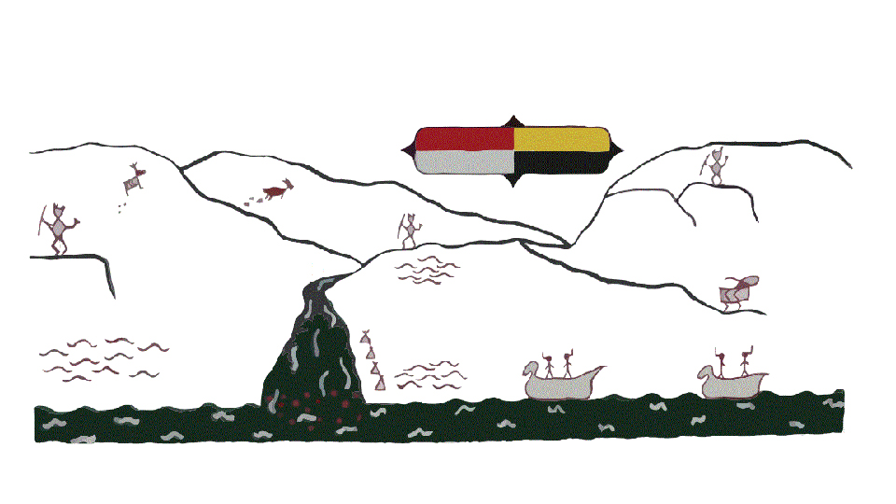
Kanaka Bar Indian Band

Home Care Support Worker
The Kanaka Bar Indian Band’s Home Care Support Worker (HCSW) works as a member of an interprofessional team responsible to deliver quality, safe, and efficient care for KBIB community members. The HCSW works directly under the HCC RN to provide home support services and promote healthy living and independence.
Roles and Responsibilities
- Work under the direction of the health care team to provide home support services to clients
- Assist clients with varied levels of care, observe, and report significant changes in the client’s presentation
- Collaborate with the health care team, clients, and their caregivers to maximize independence with activities of daily living (ADLs) and instrumental activities of daily living (IADLs)
- Establishes rapport with clients and families, and assists in promoting physical, emotional, cultural, social, and spiritual well-being of clients
- Personal care
- Assist with bathing, dressing, grooming, shampooing, oral hygiene, ambulation, transfers, range of motion exercise, safe use of equipment and assistive devices (wheelchair, walker, crutches, and cane) change of position, with toileting, commode, and incontinent care
- Handle meal planning, preparation and feeding
- Provide companionship and respite services for family
- Motivate, encourage, and involve clients in their care
- Provide input and feedback in the care planning process to the health care team.
- Perform homemaking activities which include vacuuming, dusting, sweeping, mopping floors, doing dishes, changing bed linens, doing laundry and cleaning bathrooms
Knowledge and Abilities
- Basic knowledge of client-centered care and promoting independence
- Basic knowledge of self-care and motivational support
- Demonstrates correct use of body-mechanics and knowledge of injury prevention
- Communicates effectively and in a culturally safe manner with client, caregivers, and health care team
- Demonstrated proficiency in verbal, nonverbal, and written skills through a variety of communication methods (e.g., paper and/or electronically, telephone and in-person)
- Ability to organize workload priorities within a team environment
- Ability to take direction from the health care team and clients
- Home management skills
- Physical ability to carry out the duties of the position
- Knowledge of Gentle Persuasion Approach Techniques (GPA)
- Ability to motivate clients and encourage progression though therapeutic goals
- Ability to respond effectively and appropriate in a workplace setting.
- Ability to speak Nlaka’pamuxcian an asset
- Knowledge of the Nlaka’pamux culture an asset
- Basic knowledge of home appliances (i.e., Stove, fridge, Washer, and Dryer)
Qualifications
- Graduation from a recognized Health Care Assistant Program
- Current/Active Registration with BC Community Health Worker and Care Aide Registry (Please include your number)
- Valid BC Drivers License. Local travel requires the use of personal vehicle
- Experience interacting with persons with dementia, geriatric and/or palliative population will be an asset
- Current First Aid with CPR
- Current Vulnerable Sector Criminal Record Check
- TB Test and Immunizations up to date

Preference will be given to Individuals who self-identify as First Nations, Metis or Inuit with the required combination of education and experience.

Please submit resumes to resiliencycenter@kanakabarband.ca
Position will be open until a suitable candidate is found.

Only those candidates shortlisted will be contacted for an interview

