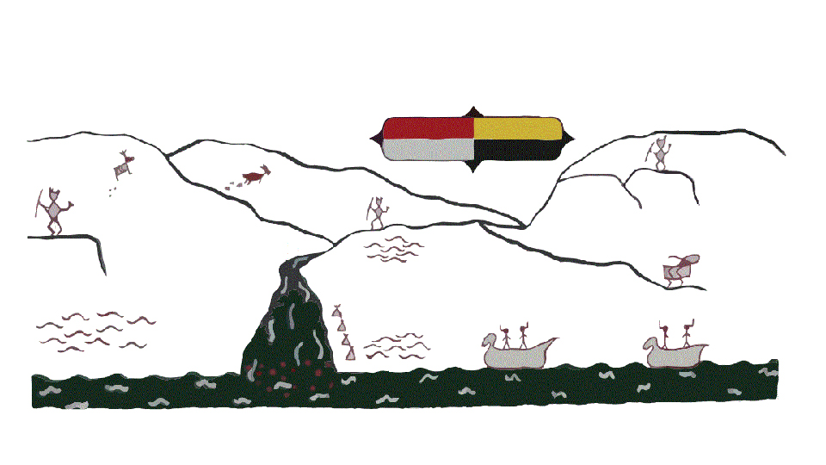
Kanaka Bar Indian Band

Job description – Kanaka Bar Youth Wellness Worker
Summary
The core of this work will be done through the drop-in program but may also include secondary programs such as gender specific groups, recreational activities groups and outreach programs. The youth worker is a primary support, coach and advocate for the youths’ needs and development.
Roles & Responsibility:
- Connect with Kanaka Bar youth ranging in age from 10-30 years old
- Plan youth programming with youth-led approach, evening, and weekend activities to engage youth.
- Build a rapport with community resources, organizations, and community members to develop new opportunities for the youth through workshops.
- Research youth opportunities, services, and programs in surrounding area.
- Connect youth with necessary and appropriate programs and services both at request and in a proactive/preventative manner.
- Establish strong, healthy, and appropriate relationships with youth
- Serve as a positive role model and support for youth as needed
- Develop and maintain a positive relationship with parents and guardians through communication.
- Post updates and program related information and scheduling, develop activity calendars, permission slips and other administrative materials
- Coordinate, plan and book all aspects of youth outings
- Seek and attend professional development opportunities to grow knowledge of relevant topics related to youth, coaching or development.
- Report to the Health Director
Knowledge, Skills & Abilities
- Ability to have a flexible schedule to meet the needs of the Band youth. Given the schedule of the client base (school), shifts will include evenings and weekends.
- Demonstrated experience with engaging youth.
- Have the emotional intelligence and are able to respond to the diverse needs of youth; are trauma informed; work efficiently and are able to prioritize competing pressures]
- Ability to engage youth in meaningful authentic discussions to explore topics that are relevant to youth development. (Suicide, sexuality, bullying etc.)
- Ability to independently supervise youth, and in instances with the support of youth volunteers
- Ability to maintain a close but appropriate relationship with youth.
- Ability to maintain client confidentiality while ensuring that safety and legal guidelines are adhered to.
- Proficient computer skills including Microsoft Office Applications (Word, Excel, Internet, and Email).
- Excellent verbal and written communication skills.
- Ability to adhere to Oath of Confidentiality and Band Policies and Procedures.
- Knowledge, respect and understanding of Kanaka Bar culture, traditions and language is considered an asset
- Ability to build the skills and capacities of the youth to be leaders in their programs, caring out the daily program activities, engaging with other youth in a meaningful way
- Ability to create opportunities for youth include local and distant activities that are both large and small scale.
- Ability to honor the youth’s voice and take their lead in program delivery.
- Ability to engage and encourage youth while maintaining an appropriate relationship with youth
- Ability to seek funding opportunities and grant writing
Qualifications/Requirements:
- Diploma in Human services/Childcare or related field of study AND 3 years of direct service OR a combination of education and experience.
- Experience working with First Nations community is considered an asset.
- Valid BC Driver’s License, Class 4.
- Food safe and first aid.
- Satisfactory Criminal Record Check and Child Intervention Check.
- Physically able to participate in up to six-hour hikes and other recreational activities.

Preference will be given to Individuals who self-identify as First Nations, Metis or Inuit with the required combination of education and experience.

Please submit resumes to resiliencycenter@kanakabarband.ca
Position will be open until a suitable candidate is found.

Only those candidates shortlisted will be contacted for an interview

